The findRT function was created to aid in the extraction of response times from audio recorded during a psychological study. It was used, for example, in the work published in:

Morash, V., Connell Pensky, A., & Miele, J. (2013). Effects of using multiple hands and fingers on haptic performance. *Perception, 42*, 759-777.

**Getting Started**

The findRT function is passed a cell-array list of audio files, or the string of a single audio file. It launches a graphical user interface (GUI) to be used in finding the response times. When the GUI is closed, the findRT function returns the response times as a list.

The following example can be run from inside the folder containing findRTs, which contains the example audio files, and the folders voicebox and signal. Type,

rts = findRTs({'example1.wma','example2.wma','example3.wma'})

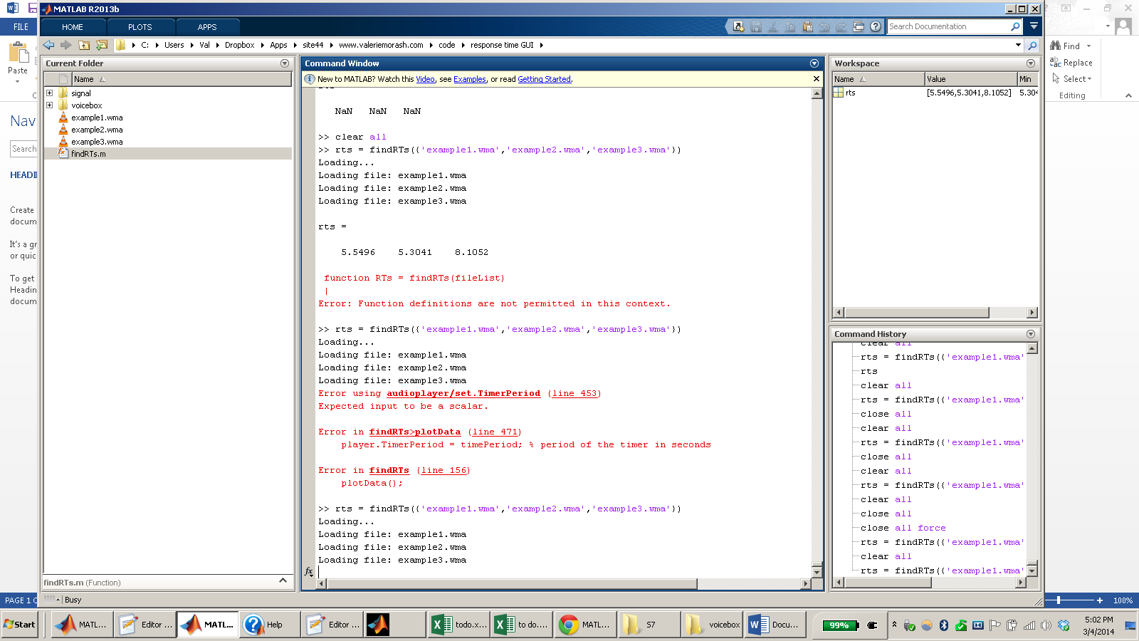

The GUI opens to show the first of the audio files, example1.wma, and its waveform. The waveform is automatically “cleaned” using minimum-mean square error spectral amplitude estimation with Voicebox,, and scaled so that the maximum absolute amplitude is 1.

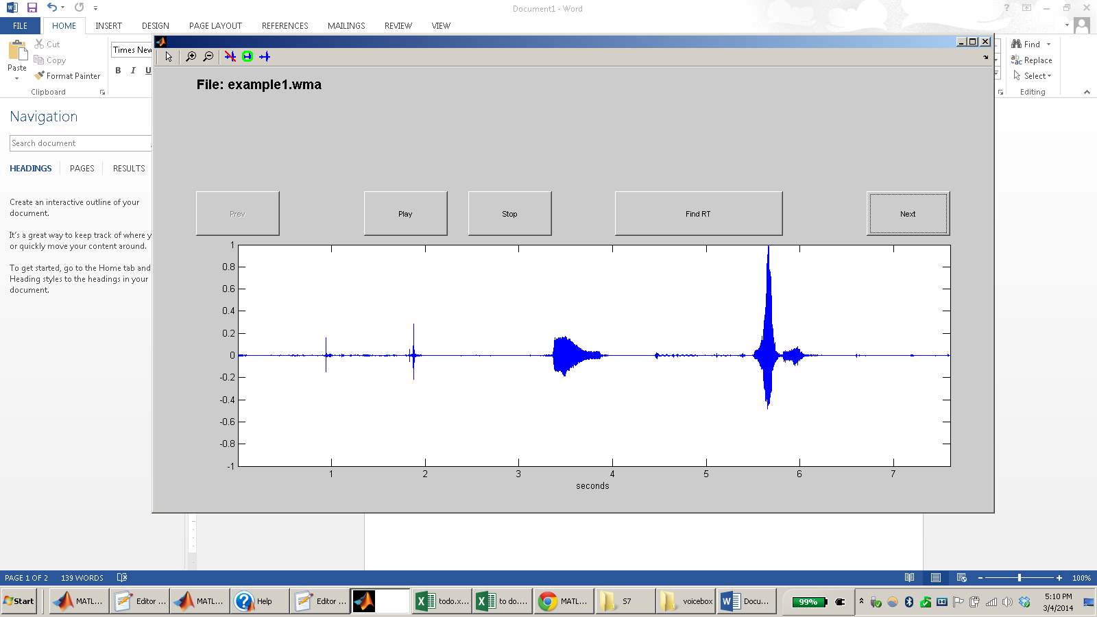

**Marking a Location in a Sound Waveform**

You can press anywhere on the waveform plot and a red line will appear (see below).

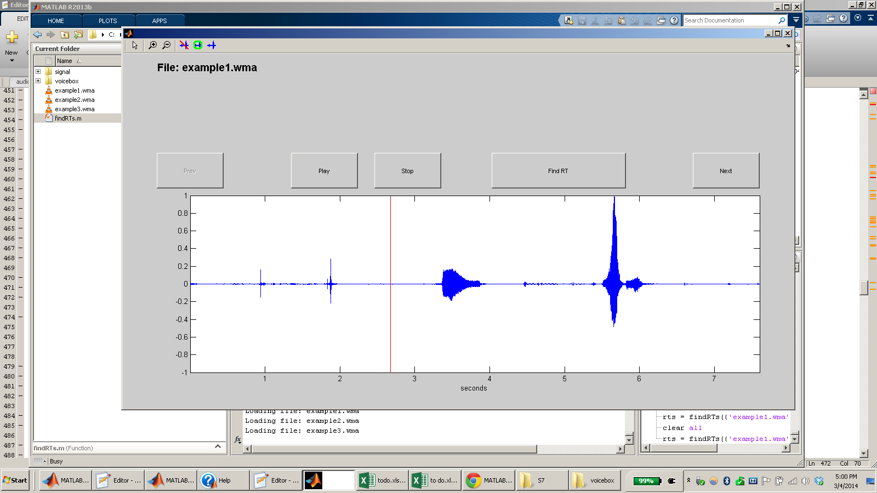

**Playing Sound**

If the waveform has been marked (with a red line), pressing the Play button will play the sound file from the time that’s marked. If not, pressing the Play button will play the sound file from its beginning. A dashed red line will follow along in the waveform while the sound is played.

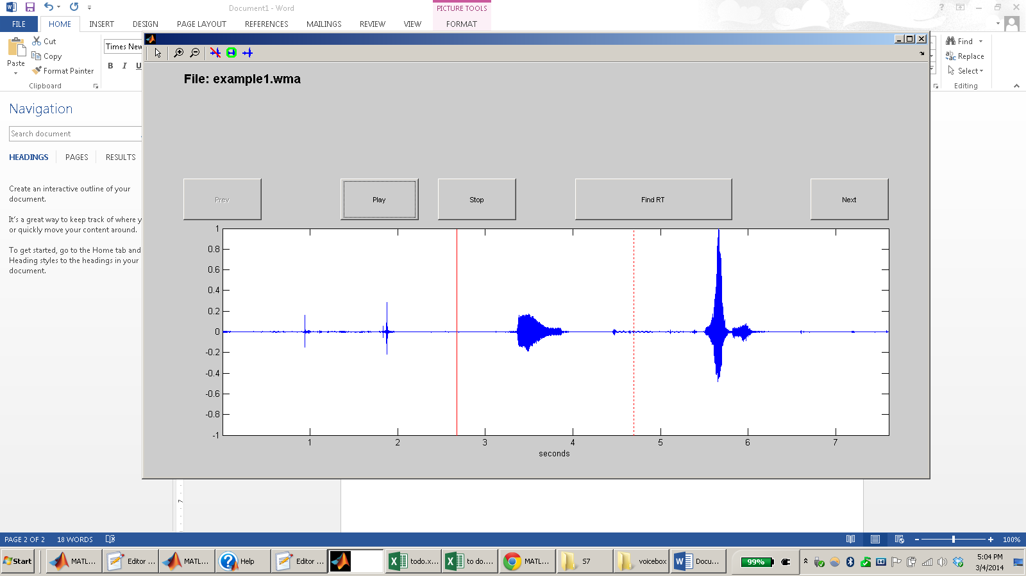

**Finding a Response Time**

Pressing Find RT will find the first instance, from the mark (red line) in which the waveform surpasses 5% maximum amplitude.

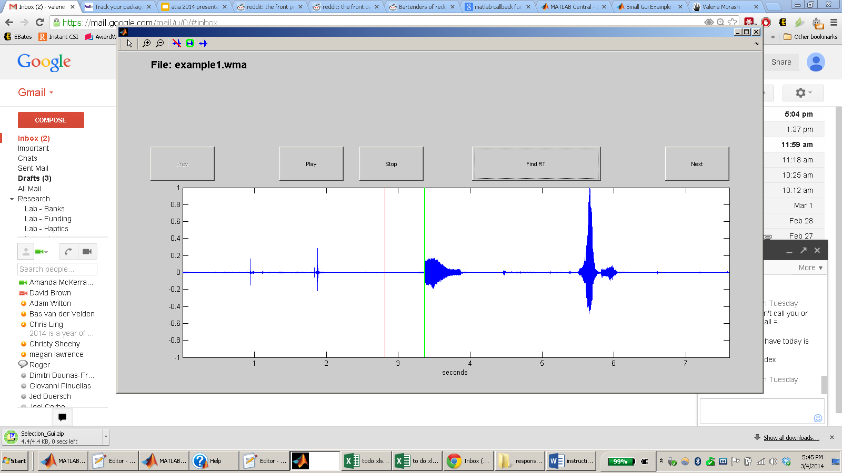

You will want to listen to the sound file to make sure that this is the participant’s answer, and not a cough or some other noise. In the example above, the RT found is *not* the participant’s answer, which appears later. Therefore, the mark should be moved, and Find RT should be pressed again.

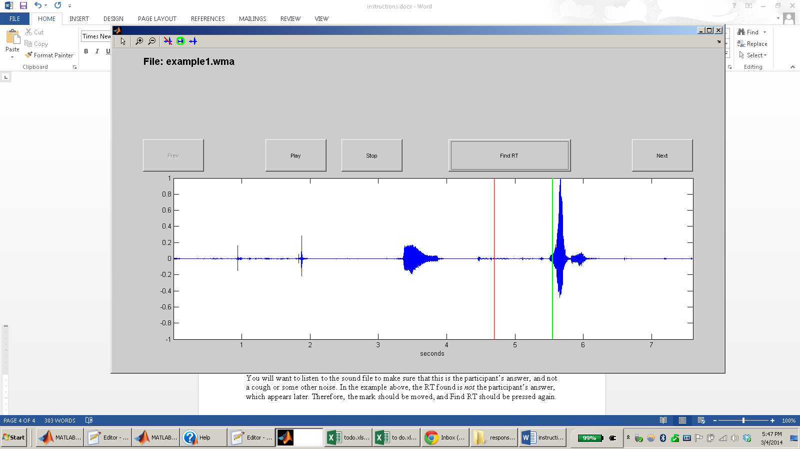

**Moving Between Files**

The Next and Prev buttons allow you to move between sound files in your list.

**Zooming**

To get a better view of a waveform, for example if two sounds are close together and you want to mark between them, use the zoom-in button in the upper left, and then select the area on the waveform you would like to view in more detail: 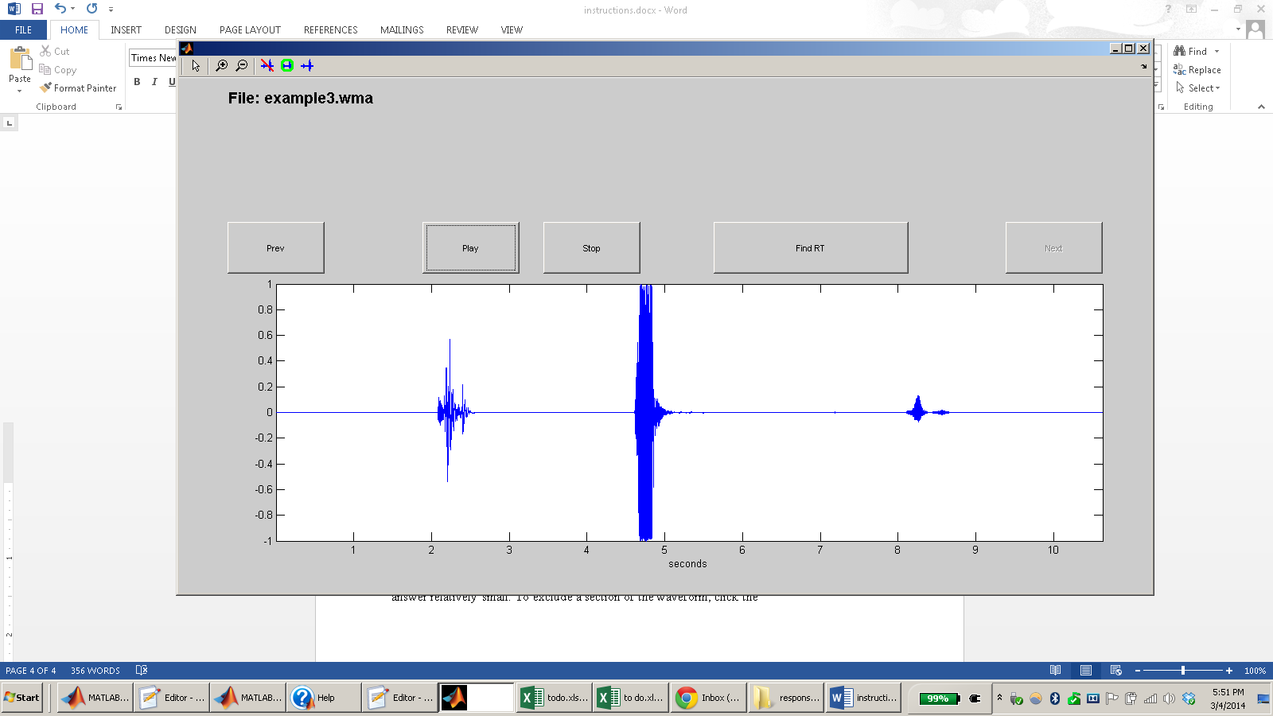

You can zoom out using the zoom-out button: 

And you can exit zoom-mode using the arrow button: 

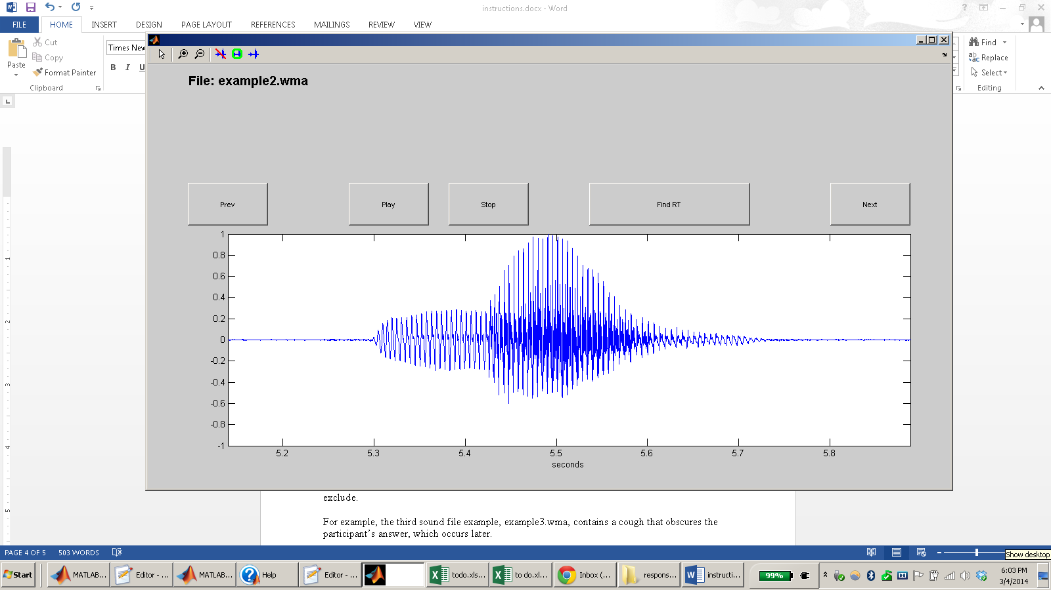

**Excluding Sections of the Waveform**

If the participant made a loud noise, like a cough, it can make the amplitude of the participant’s answer relatively small. To exclude a section of the waveform, click the toolbar button that shows the waveform with a line through it: 

Then select the portion of the waveform (by highlighting it with the mouse) that you want to exclude.

For example, the third sound file example, example3.wma, contains a cough that obscures the participant’s answer, which occurs later.

The large sound in the middle of this waveform is the cough, and the answer is to the right.

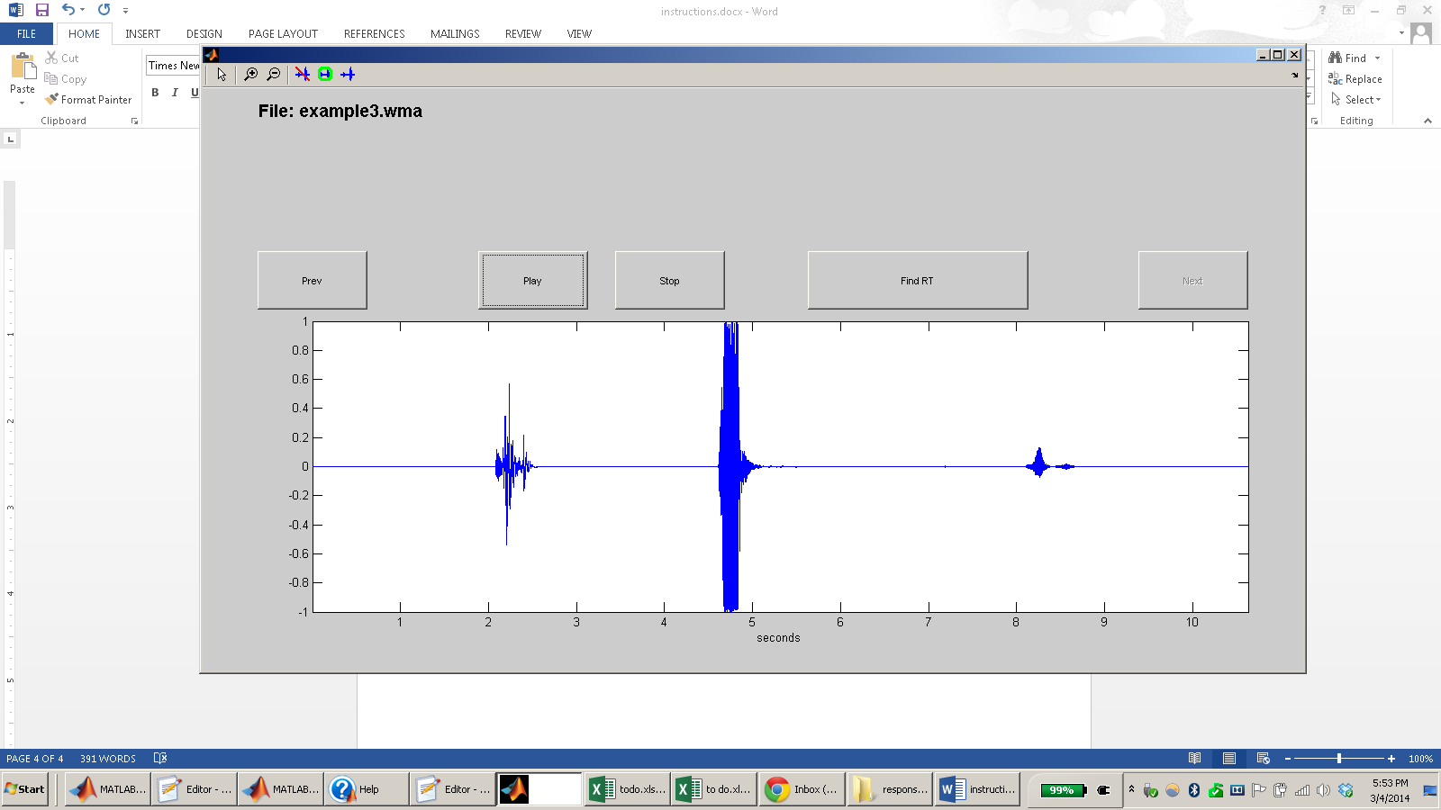

Removing the cough results in the following waveform.

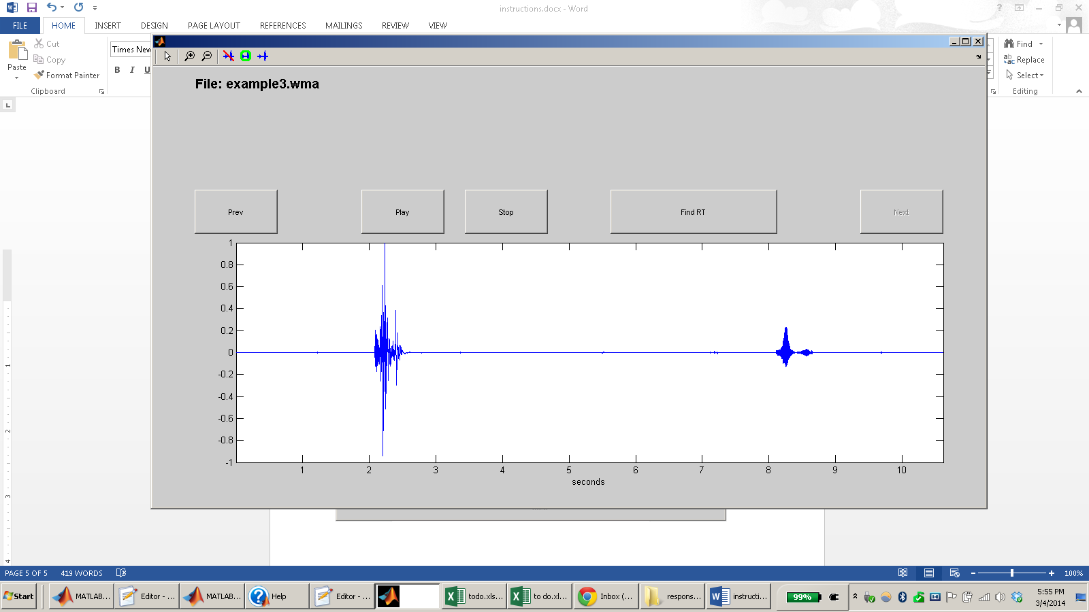

If you press the  button, and decide you do want to go back to the arrow, press 

**Focusing on Sections of the Waveform**

Instead of excluding only small sections of the waveform, you may want to exclude everything except a certain section. To focus on a section of the waveform, and exclude everything else, use the  button. Using this button to focus on only the response from example 3 produces the following waveform.

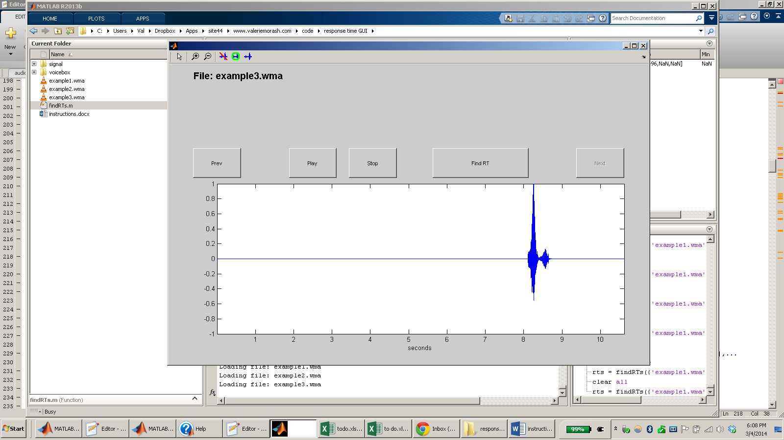

**Restore Waveform**

To restore the waveform to its original state, removing any exclusions or focusing, use the  button.

**Getting RTs**

Closing the GUI returns the found RTs.

